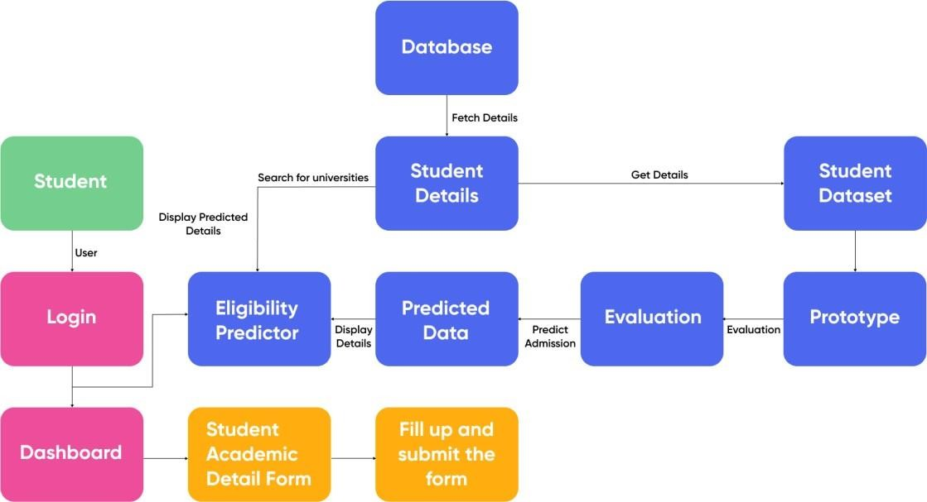

**PROJECT DESIGN PHASE-II DATA FLOW DIAGRAM & USER STORIES**

|  |  |
| --- | --- |
| Date | 1 November 2022 |
| Team ID | PNT2022TMID54205 |
| Project Name | University Admit Eligibility Predictor |
| Maximum Marks | 4 Marks |

**Data Flow Diagrams:**

A data flow diagram (DFD) maps out the flow of information for any process or system. It uses defined symbols like rectangles, circles and arrows, plus short text labels, to show data inputs, outputs, storage points and the routes between each destination. A neat and clear DFD can depict the right amount of the system requirement graphically. It shows how data enters and leaves the system, what changes theinformation, and where data is stored.

**User Stories**

Use the below template to list all the user stories for the product.

|  |  |  |  |  |  |  |
| --- | --- | --- | --- | --- | --- | --- |
| **User Type** | **Functional**  **Requireme nt (Epic)** | **User Story Number** | **User Story / Task** | **Acceptance criteria** | **Priority** | **Release** |
| Customer | Landing page | USN-1 | As a user, I am able to view information and details about the university | I am able to access the university landing  page | Medium | Sprint-1 |
|  |  | USN-2 | As a user, I am able to view the current news about the university | I am able to access the latest nesws. | Medium | Sprint-1 |
|  |  | USN-3 | As a user, I am able to fill a form to contact the university with queries | I am able to fill and submit thecontact form | Low | Sprint-2 |
|  |  | USN-4 | As a user, I am able to go through the social media pages of the university | I am able to reach out to themvia social media | Medium | Sprint-1 |
|  |  | USN-5 | As a user, I am able to see testimonials of students who have passed out from that university | I am able to access the testimonials | Medium | Sprint-1 |
|  | Admissions | USN-6 | As a user, I am able to see the cut off marks of past years. | I am able to download the  previous year cut- off details | High | Sprint-2 |
|  |  | USN-7 | As a user, I am able to access details of previous alumni. | I am able to  access the details | Medium | Sprint-2 |
| of alumni ofthe |
| university |
|  |  | USN-8 | As a user, I am able to predict my | I am able to get | High | Sprint-2 |
| admission eligibility for the university | result aseither |
|  | eligible/not |
|  | eligible |

|  |  |  |  |  |  |  |
| --- | --- | --- | --- | --- | --- | --- |
|  | Courses offered | USN-9 | As a user, I am able to view the courses offered by  the university for PG students | I am able to access the course  details | Medium | Sprint-3 |
|  | Events | USN-10 | As a user, I am able check the various technical events about to happen in the university | I can register for the events | Low | Sprint-3 |

|  |  |  |  |  |  |  |
| --- | --- | --- | --- | --- | --- | --- |
|  | E-books | USN-11 | As a user, I am able to download and read e- books relating to visa formalities | I can download the e- books | High | Sprint-3 |
|  |  |  |  |  |  |  |

|  |  |  |  |  |  |  |
| --- | --- | --- | --- | --- | --- | --- |
| **User Type** | **Functional Requireme nt (Epic)** | **User Story Number** | **User Story / Task** | **Acceptance criteria** | **Priority** | **Release** |
|  | Scholarship | USN-12 | As a user, I will be able to find  resources regarding scholarship availability | I can access scholarship  resources | High | Sprint-4 |
|  | Test prep materials | USN-13 | As a user, I will be able to download and read GRE, TOEFL test preparation  materials | I can download test preparation materials | Medium | Sprint-4 |
| Administrator | Landing page | USN-14 | As an administrator, I will be able  to update the news about the university | I can check if the  update is reflected or not | Medium | Sprint-4 |
|  | Events | USN-15 | As an administrator, I will be able to update the list  of activities to be hosted | I can check if the update  is reflected or not | Medium | Sprint-4 |